Bluenose Golf Club 
Ladies Field Day 2026
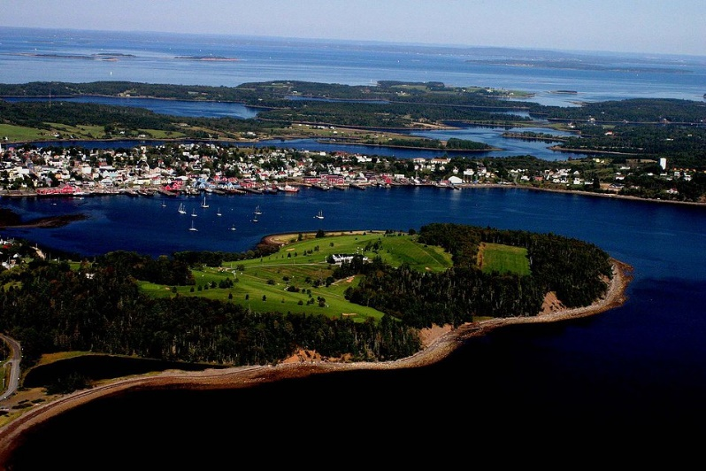
Tuesday, July 21st – 9:00 AM Shot Gun Start
2 Person Scramble Format
Members $50.00 per player / Non-Members $80.00 per player
Price includes golf, meal and prizing.
Registration opens May 21st
Deadline is July 10th. No refunds after this date.
Entry is first come, first serve. Contact Pro Shop to enter.
Power carts can be reserved at time of entry submission.

902-634-4260

